

Dortos Engineering-Second Issue: New Security Regulation



Shane Ẽire Byrne

NTC300

**Abstract**

The inherent issue given is new security regulation requires the assurance of a 3 second response time to ensure the user’s flow of thought remains uninterrupted because of the sensitive nature of data on the system. This material will explore various avenues one can take in order to alleviate and speed up system response times in order to meet this new requirement upon the system.

**Response Times**

Response time in a nutshell is the total amount of time it takes to respond to a request for a service. This can be anything from a memory fetch from an HDD, a database query, connecting to a server, or even loading a webpage. Response times are generally measured in Time to First Byte (TTFB) which is measured in milliseconds. Response times are usually how many milliseconds it takes a system to process a request. (Simic, 2019)

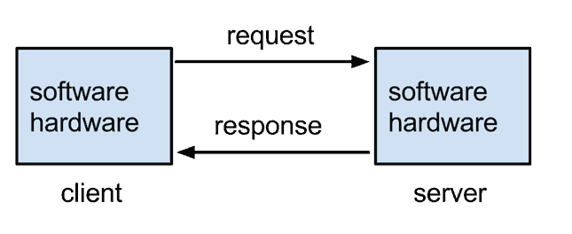

Diagram taken from (Simic, 2019)

One possible elevation to a lagging response time is the use of a Content Delivery Network (CDN). A CDN is a framework of distributed networks of proxy servers and their data centers. These are distributed over a large geographic area traditionally to provide content to users as fast as possible (Simit, 2019). The utilization of a CDN can help to improve end users experience and lower abandon rates of a service. They can improve conversion rate and improve customer loyalty. CDN’s can also help with web security in such matters as absorbing and mitigating a Denial of Service (DOS) attack (Akami, 2020).

Another means to improve response times is by optimizing databases. If response time issues is lagging because of a lagging data base there are means by which to fix it. First off, it is advisable to have a sorted database, this will require the interfacing program attached to the database to require less computational needs from the system in order to retrieve the data being asked for. Cleaner queries that are more concise in what is being asked for will also put less strain on the system and provide better response times. A properly indexed database will also speed up the over all process. For SQL based databases, limiting or avoiding the use of temporary tables will help speed up response times (Thumar, C).

Scripting can also adversely affect response times. Ensuring scripts that establish software used to connect applications is running at its peak efficiency is also a means to fix lagging response times (Boudol, 2006). Software languages such as PHP do require periodical updates and patches, without these bugs can still exist within the code and cause issues further on down the line. Non-updated software might also cause a greater drainage of vital system resources (Simic, 2019). Also, the minification of code and the simplification of it may help to alleviate system load times, removal of unnecessary lines and comments will produce less demand on the systems reading said script (Simic, 2019).

Improvement of caching can also help in improving response times. A cache is the storage of recently used information so that it can be quickly accessed later. This can be a browser cache, memory cache (typically stored in RAM), a disk cache (ram on an HDD or SSD), or on a processor itself (TechTerms, 2020). Without the proper caching of data, it can produce unnecessary waiting periods for the end user as the software in the system itself has to find and reload the data the end user is seeking (Keycdn, 2018).

In summation, we have explored various means by which to increase system response times. We have explored various software’s, techniques, and tools one can utilize to meet the 3 second response time initiative as part of the new regulation. A few items explored were the possible use of a CDN in order to limit a response time. Cleaning up the code the software is comprised of and possibly adjusting its algorithm(s) in order to get better performance out of it is another possible solution. Also, the importance of caching, and how if done properly it can have a less drastic effect on the system over all and free up more system resources to assist in the end users needs.

**References**

Akami. (2020). Content Distribution Network. Retrieved from

<https://www.akamai.com/us/en/resources/content-distribution-network.jsp>

Boudol, G. (2006). Foundations of Software Technology and Theoretical

Computer Science: 26th International Conference . New Deli, India: Springer.

Simic, S. (2019). 7 Ways To Reduce Server Response Time. Retrieved from

<https://phoenixnap.com/kb/reduce-server-response-time>

Thumar, C. (2016). 6 ways to optimize your SQL database. Retrieved from

<https://jaxenter.com/6-ways-optimize-sql-database-136448.html>

 Keycdn. (2018). How to Improve Server Response Time. Retrieved from

<https://www.keycdn.com/support/server-response-time>

TechTerms. (2020). Cache. Retrieved from <https://techterms.com/definition/cache>